Plotting Quadratic Graphs 1
Here is the graph y = x² + 2x + 3
Notice that it has a line of symmetry which has been plotted as a dotted line.
Using Geogebra, plot other graphs in the form y = x² + bx + c
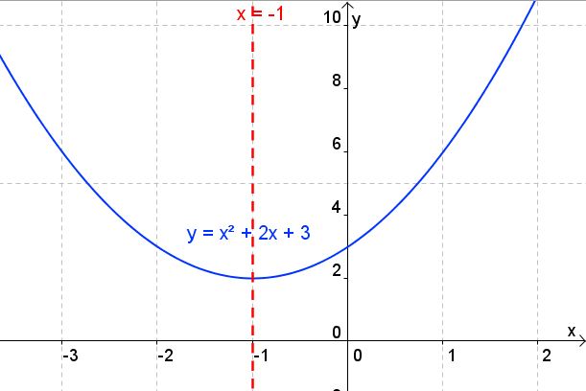
What effect does b have on the graph?
What effect does c have on the graph?
Can you work out the equation of the line of symmetry from the equation?

Now go to Geogebra file Copy My Graph 1 and make each of the graphs.
Put the equations to the five graphs here
- Qu1
- Qu2
- Qu3
- Qu4
- Qu5

Complete the square for this quadratic expression
x² + 4x + 1
Go to Completing the square form of parabolas
Once you have understood what is going on go to Geogebra file Copy My Graph 2 and make each of the graphs.
Put the equations to the five graphs here
- Qu1
- Qu2
- Qu3
- Qu4
- Qu5

