The Student Survey – Quartiles and Box Plots
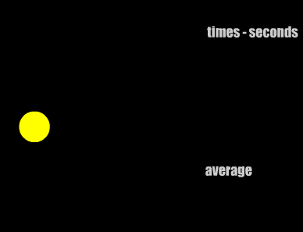
If you took part in the student survey you will have completed the reaction time game http://www.mathsisfun.com/games/reaction-time.html
You have to click when the circle changes colour.

In this activity we will consider whether “Reaction time is dependent upon age”.
- Circle which you think is likely to be true:
- Older people will have faster reaction times.
- Younger people will have faster reaction times.
- Age has no influence on reaction time.

Below you will find the reaction times of the students grouped by age (they have been ordered to make this easier for you). Obviously erroneous data has been removed.
- Find the minimum value, lower quartile (Q1), median (Q2), upper quartile (Q3) and maximum value for the individual groups and complete the table below
Age group | min | Q1 | Q2 | Q3 | max
11-14
15-18
>18

- Plot 3 separate boxplots on the grid on page 3 like this
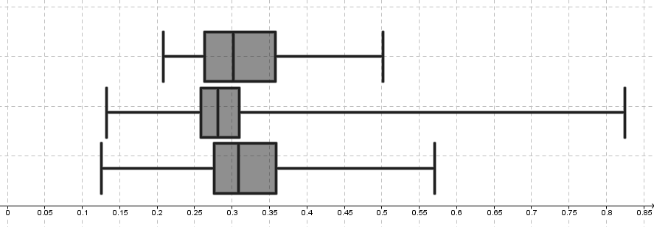

11-14 y olds |  |  |  |  |  |  | 15-18 y olds |  |  |  |  |  |  | >18 y olds
1 | 0.126 | 51 | 0.282 | 101 | 0.352 |  | 1 | 0.132 | 51 | 0.274 | 101 | 0.319 |  | 1 | 0.216
2 | 0.199 | 52 | 0.283 | 102 | 0.354 |  | 2 | 0.132 | 52 | 0.275 | 102 | 0.32 |  | 2 | 0.228
3 | 0.204 | 53 | 0.284 | 103 | 0.355 |  | 3 | 0.195 | 53 | 0.276 | 103 | 0.322 |  | 3 | 0.234
4 | 0.208 | 54 | 0.285 | 104 | 0.356 |  | 4 | 0.21 | 54 | 0.276 | 104 | 0.335 |  | 4 | 0.242
5 | 0.211 | 55 | 0.285 | 105 | 0.357 |  | 5 | 0.211 | 55 | 0.277 | 105 | 0.336 |  | 5 | 0.26
6 | 0.22 | 56 | 0.285 | 106 | 0.358 |  | 6 | 0.211 | 56 | 0.278 | 106 | 0.344 |  | 6 | 0.261
7 | 0.234 | 57 | 0.287 | 107 | 0.359 |  | 7 | 0.222 | 57 | 0.279 | 107 | 0.344 |  | 7 | 0.263
8 | 0.239 | 58 | 0.288 | 108 | 0.359 |  | 8 | 0.224 | 58 | 0.28 | 108 | 0.345 |  | 8 | 0.266
9 | 0.243 | 59 | 0.288 | 109 | 0.359 |  | 9 | 0.234 | 59 | 0.281 | 109 | 0.345 |  | 9 | 0.266
10 | 0.244 | 60 | 0.288 | 110 | 0.361 |  | 10 | 0.237 | 60 | 0.281 | 110 | 0.345 |  | 10 | 0.278
11 | 0.244 | 61 | 0.290 | 111 | 0.361 |  | 11 | 0.237 | 61 | 0.282 | 111 | 0.351 |  | 11 | 0.28
12 | 0.245 | 62 | 0.292 | 112 | 0.361 |  | 12 | 0.238 | 62 | 0.282 | 112 | 0.364 |  | 12 | 0.287
13 | 0.25 | 63 | 0.294 | 113 | 0.362 |  | 13 | 0.239 | 63 | 0.284 | 113 | 0.365 |  | 13 | 0.294
14 | 0.251 | 64 | 0.295 | 114 | 0.362 |  | 14 | 0.239 | 64 | 0.284 | 114 | 0.373 |  | 14 | 0.317
15 | 0.254 | 65 | 0.296 | 115 | 0.364 |  | 15 | 0.24 | 65 | 0.284 | 115 | 0.383 |  | 15 | 0.343
16 | 0.254 | 66 | 0.296 | 116 | 0.365 |  | 16 | 0.241 | 66 | 0.284 | 116 | 0.409 |  | 16 | 0.352
17 | 0.254 | 67 | 0.298 | 117 | 0.368 |  | 17 | 0.243 | 67 | 0.284 | 117 | 0.424 |  | 17 | 0.362
18 | 0.255 | 68 | 0.299 | 118 | 0.368 |  | 18 | 0.249 | 68 | 0.285 | 118 | 0.442 |  | 18 | 0.385
19 | 0.258 | 69 | 0.302 | 119 | 0.368 |  | 19 | 0.249 | 69 | 0.287 | 119 | 0.461 |  | 19 | 0.443
20 | 0.259 | 70 | 0.302 | 120 | 0.370 |  | 20 | 0.25 | 70 | 0.287 | 120 | 0.567
21 | 0.260 | 71 | 0.307 | 121 | 0.374 |  | 21 | 0.25 | 71 | 0.288 | 121 | 0.657
22 | 0.260 | 72 | 0.307 | 122 | 0.378 |  | 22 | 0.253 | 72 | 0.289 | 122 | 0.825
23 | 0.26 | 73 | 0.309 | 123 | 0.378 |  | 23 | 0.253 | 73 | 0.293
24 | 0.26 | 74 | 0.309 | 124 | 0.378 |  | 24 | 0.253 | 74 | 0.293
25 | 0.262 | 75 | 0.310 | 125 | 0.38 |  | 25 | 0.255 | 75 | 0.295
26 | 0.262 | 76 | 0.310 | 126 | 0.382 |  | 26 | 0.256 | 76 | 0.295
27 | 0.263 | 77 | 0.313 | 127 | 0.383 |  | 27 | 0.257 | 77 | 0.296
28 | 0.264 | 78 | 0.313 | 128 | 0.387 |  | 28 | 0.258 | 78 | 0.297
29 | 0.265 | 79 | 0.314 | 129 | 0.388 |  | 29 | 0.258 | 79 | 0.298
30 | 0.268 | 80 | 0.317 | 130 | 0.396 |  | 30 | 0.259 | 80 | 0.299
31 | 0.268 | 81 | 0.32 | 131 | 0.397 |  | 31 | 0.259 | 81 | 0.299
32 | 0.269 | 82 | 0.32 | 132 | 0.414 |  | 32 | 0.259 | 82 | 0.301
33 | 0.269 | 83 | 0.321 | 133 | 0.418 |  | 33 | 0.26 | 83 | 0.301
34 | 0.271 | 84 | 0.324 | 134 | 0.424 |  | 34 | 0.26 | 84 | 0.301
35 | 0.273 | 85 | 0.326 | 135 | 0.444 |  | 35 | 0.26 | 85 | 0.302
36 | 0.274 | 86 | 0.327 | 136 | 0.452 |  | 36 | 0.262 | 86 | 0.302
37 | 0.274 | 87 | 0.327 | 137 | 0.453 |  | 37 | 0.264 | 87 | 0.303
38 | 0.274 | 88 | 0.327 | 138 | 0.463 |  | 38 | 0.265 | 88 | 0.304
39 | 0.275 | 89 | 0.33 | 139 | 0.464 |  | 39 | 0.266 | 89 | 0.304
40 | 0.276 | 90 | 0.334 | 140 | 0.464 |  | 40 | 0.266 | 90 | 0.304
41 | 0.276 | 91 | 0.335 | 141 | 0.502 |  | 41 | 0.268 | 91 | 0.308
42 | 0.277 | 92 | 0.337 | 142 | 0.571 |  | 42 | 0.268 | 92 | 0.308
43 | 0.277 | 93 | 0.340 |  |  |  | 43 | 0.269 | 93 | 0.31
44 | 0.277 | 94 | 0.342 |  |  |  | 44 | 0.27 | 94 | 0.31
45 | 0.278 | 95 | 0.344 |  |  |  | 45 | 0.271 | 95 | 0.31
46 | 0.278 | 96 | 0.344 |  |  |  | 46 | 0.272 | 96 | 0.313
47 | 0.278 | 97 | 0.344 |  |  |  | 47 | 0.273 | 97 | 0.314
48 | 0.28 | 98 | 0.349 |  |  |  | 48 | 0.273 | 98 | 0.314
49 | 0.28 | 99 | 0.35 |  |  |  | 49 | 0.273 | 99 | 0.315
50 | 0.281 | 100 | 0.351 |  |  |  | 50 | 0.273 | 100 | 0.317

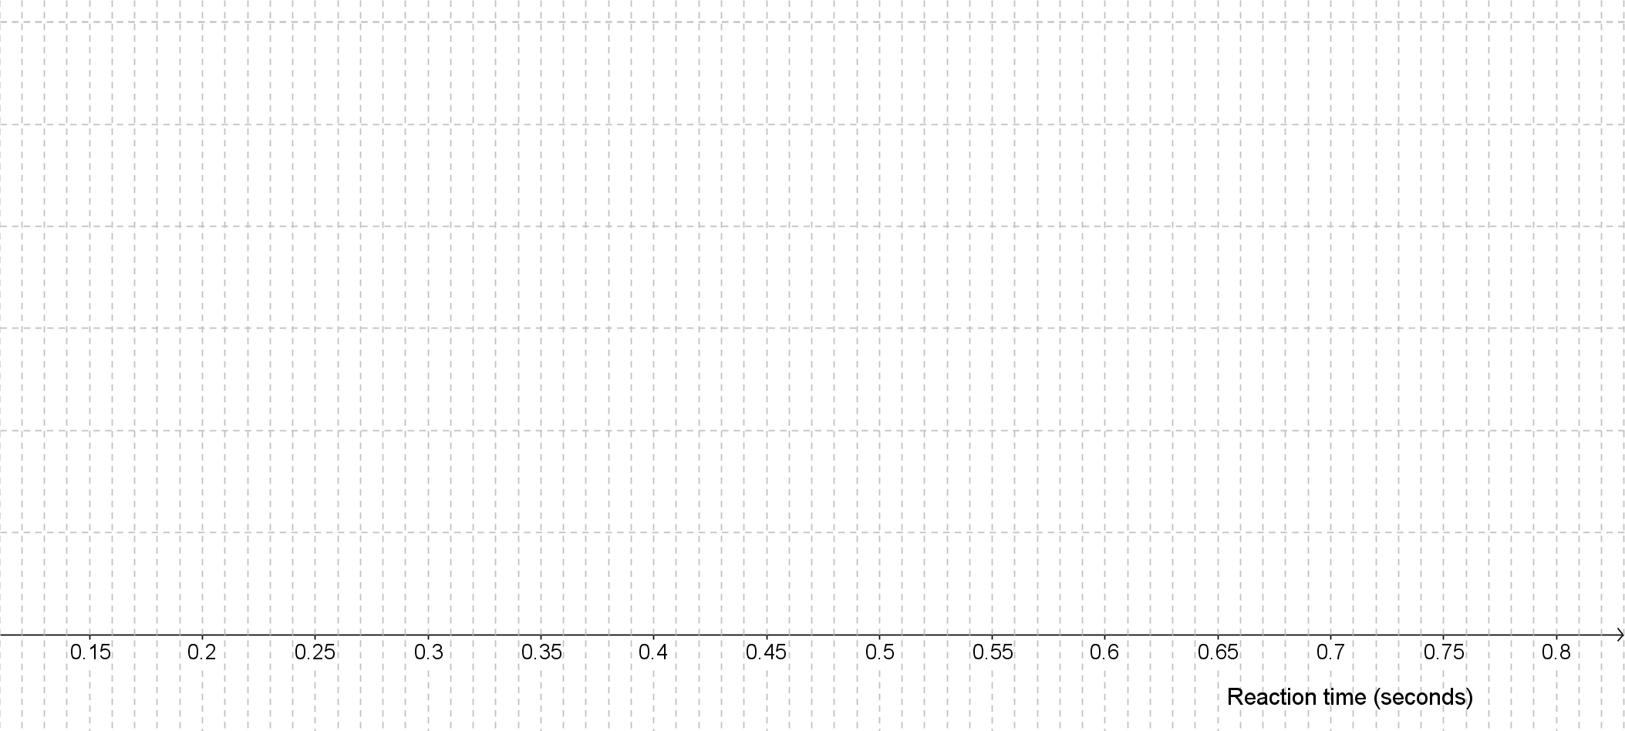

- Describe what you notice about the boxplots. Does this support your hypothesis in Q1?
…………………………………………………………………………………………………………………………………………………………………………………..…………………………………………………………………………………………………………………………………………………………………………………..…………………………………………………………………………………………………………………………………………………………………………………………………………………………………………………..………………………………………………………………………………………………………………………………

